**A5D3x Start Up**

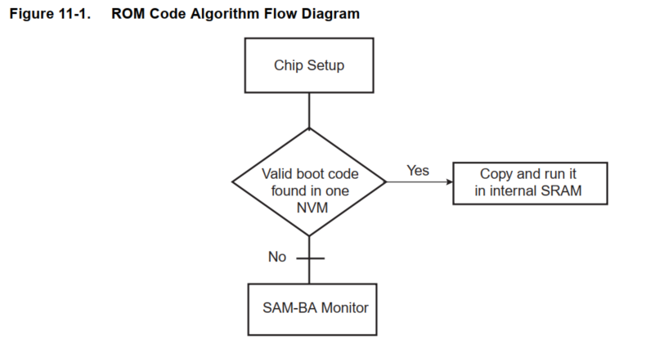

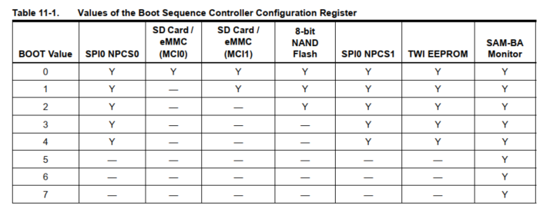

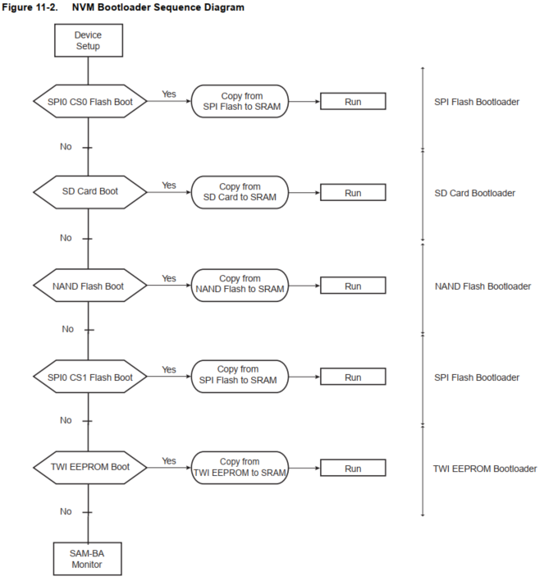

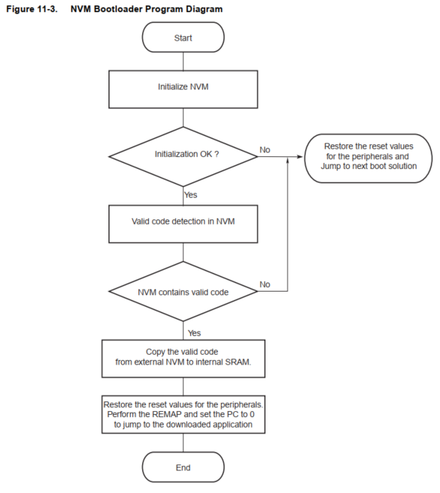

**Chip Setup**

At the boot start up, PCK &MCK is 12MHz RC

Y

N

Y

Y

After reset, the 8 -48MHz crystal oscillator is disabled (Page 222, A5D36)

Reset

BMS = 1 ?

EBI Nor Flash

Stack Setup to supervisor mode

MCK to 32K RC En XOSC bypass

MOSCSELS = 1?

Dis bypass

MOSCXTS & MOSCSELS = 1?

N

MCK,PCK to Main Clock

MCK to 12M RC

C Variable init

PLLA configured

PCK 96M MCK 48M

OSC 12,16,24,48M

MCK to 12M RC

N

Y

En Usb

Dis USB

MOSCXTS: When disable this OSC by CKGR_MOR.MOSCXTEN, the PMC_SR.MOSCXTS is automatically cleared

MOSCXTST: XOSC startup time

MOSCSELS: Main Oscillator Selection status, it indicates the MCK switch is done



Page 222